Biomarker for autism discovered

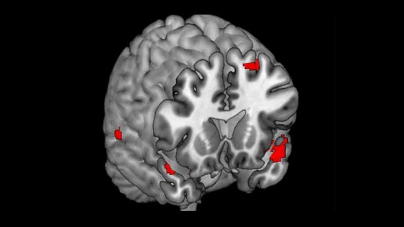

Research provides opportunity for identifying genes linked to autism.

Siblings of people with autism show a similar pattern of brain activity to that seen in people with autism when looking at emotional facial expressions.

The University of Cambridge researchers identified the reduced activity in a part of the brain associated with empathy and argue it may be a ‘biomarker’ for a familial risk of autism.

Dr Michael Spencer, who led the study from the University’s Autism Research Centre, said: “The findings provide a springboard to investigate what specific genes are associated with this biomarker.

The brain’s response to facial emotion could be a fundamental building block in causing autism and its associated difficulties.”

The Medical Research Council funded study is published today, 12th July, in the journal *Translational Psychiatry.*

Previous research has found that people with autism often struggle to read people’s emotions and that their brains process emotional facial expressions differently to people without autism.

However, this is the first time scientists have found siblings of individuals with autism have a similar reduction in brain activity when viewing others’ emotions.

In one of the largest functional MRI (fMRI) studies of autism ever conducted, the researchers studied 40 families who had both a teenager with autism and a sibling without autism.

Additionally, they recruited 40 teenagers with no family history of autism.

The 120 participants were given fMRI scans while viewing a series of photographs of faces which were either neutral or expressing an emotion such as happiness.

By comparing the brain’s activity when viewing a happy verses a neutral face, the scientists were able to observe the areas within the brain that respond to this emotion.

Despite the fact that the siblings of those with autism did not have a diagnosis of autism or Asperger syndrome, they had decreased activity in various areas of the brain (including those associated with empathy, understanding others’ emotions and processing information from faces) compared to those with no family history of autism.

The scans of those with autism revealed that the same areas of the brain as their siblings were also underactive, but to a greater degree.

(These brain regions included the temporal poles, the superior temporal sulcus, the superior frontal gyrus, the dorsomedial prefrontal cortex and the fusiform face area.)

Because the siblings without autism and the controls differed only in terms of the siblings having a family history of autism, the brain activity differences can be attributed to the same genes that give the sibling their genetic risk for autism.

Explaining why only one of the siblings might develop autism when both have the same biomarker, Dr Spencer said: “It is likely that in the sibling who develops autism additional as yet unknown steps – such as further genetic, brain structure or function differences – take place to cause autism.”

It is known that in a family where one child already has autism, the chances of a subsequent child developing autism are at least 20 times higher than in the general population.

The reason for the enhanced risk, and the reason why two siblings can be so differently affected, are key unresolved questions in the field of autism research, and Dr Spencer’s group’s findings begin to shed light on these fundamental questions.

Professor Chris Kennard, chairman of the Medical Research Council funding board for the research, said: “This is the first time that a brain response to different human facial emotions has been shown to have similarities in people with autism and their unaffected brothers and sisters.

Innovative research like this improves our fundamental understanding of how autism is passed through generations affecting some and not others.

This is an important contribution to the Medical Research Council’s strategy to use sophisticated techniques to uncover underpinning brain processes, to understand predispositions for disease, and to target treatments to the subtypes of complex disorders such as autism.”